Critical vulnerabilities and Zero-Days
Critical vulnerabilities and zero-day threats represent high-stakes challenges in cybersecurity.
Because zero-day threats are by definition unknown (no patch or signature exists), your focus must shift from preventing the initial exploitation to minimizing the blast radius and rapidly restoring operations
The best way to prepare for and solve critical vulnerabilities and zero-day events is to move beyond signature-based detection and adopt a proactive, resilience-oriented strategy grounded in a structured framework like the NIST Cybersecurity Framework (CSF) 2.0. (fig.1)
Feature | Critical Vulnerability | Zero-Day Vulnerability
Vendor Knowledge | Known | Unknown
Defense Strategy | Patch Management | Behavioral Monitoring & Isolation
Reaction Time | Scheduled (Prioritized) | Immediate (Crisis Response)
Primary Danger | Delayed patching | Undetectable initial breach

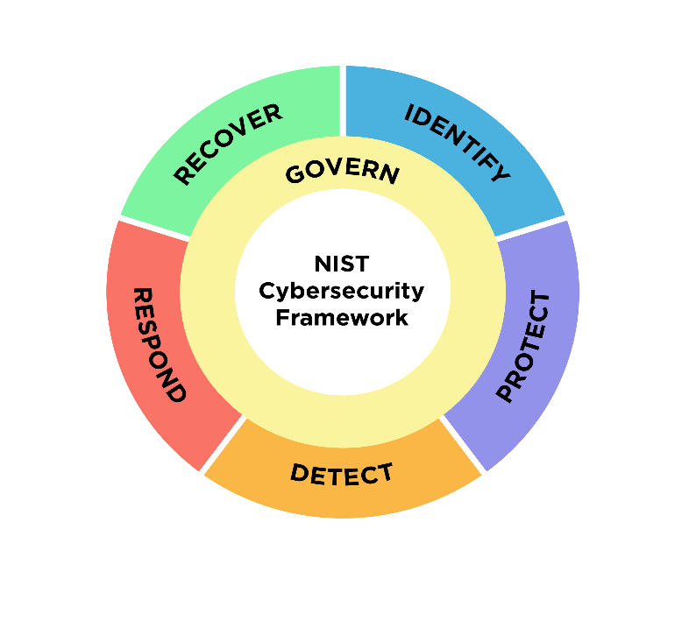Fig.1
NIST Framework relation with Zero-Day Scenarios (Fig.2)

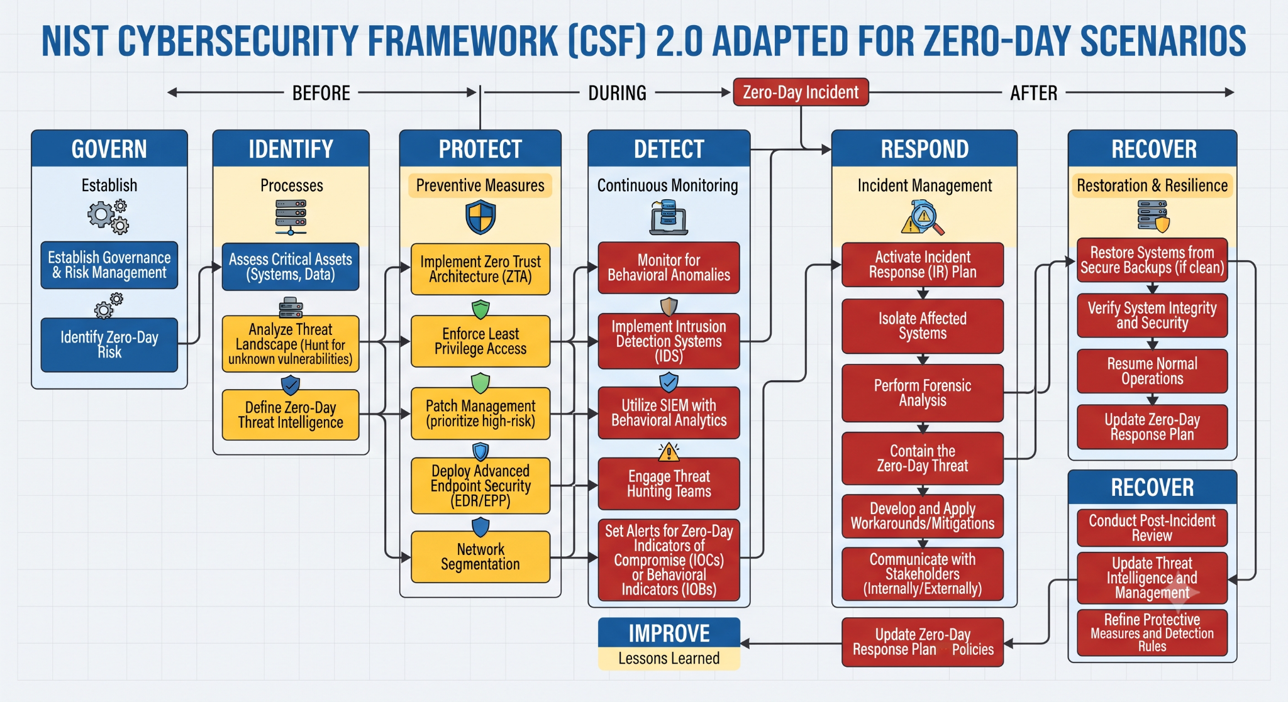
Fig.2
GOVERNANCE PHASE
Governance
Under the NIST model, governance is defined as the establishment, communication, and monitoring of an organization’s cybersecurity risk management strategy, expectations, and policies. It is a core component of corporate governance, focused on risk governance and accountability.
The Govern function serves as the "overarching" structure for the other five functions: Identify, Protect, Detect, Respond, and Recover. While these latter functions involve the actual technical and operational execution of security, the Govern function dictates the strategy and priorities for those actions.

Implementation Tiers
To help organizations measure their governance maturity, NIST utilizes Implementation Tiers (ranging from Tier 1, "Partial," to Tier 4, "Adaptive"):
- Tier 1 (Partial): Governance is informal or non-existent; cybersecurity activities are reactive.
- Tier 2 (Risk Informed): There is increased awareness, but governance is not yet consistent or organization-wide.
- Tier 3 (Repeatable): Governance is formalized, and management has implemented an organization-wide, repeatable risk management process.
- Tier 4 (Adaptive): Cybersecurity is fully integrated into organizational culture and business strategy. Governance is data-driven, predictive, and constantly evolving to address new threats.
General Concepts and Preparation Strategies
- NIST Incident Response Preparation: Detailed guidance on the importance of the preparation phase, including asset inventory and communication planning. l
- Zero-Day Lifecycle and Defence-in-Depth: An overview of how behavioural detection and layered security mitigate unknown threats.
- Zero-Trust Architecture: Modern security frameworks that focus on continuous verification to limit the movement of attackers.
- Incident Response Planning: Practical steps for developing a response plan that accounts for unpatched vulnerabilities
The preparation phase is often considered the most critical stage of incident response when dealing with zero-days scenarios. Because vulnerabilities in these scenarios are unknown and there are no available patches, the preparation phase focuses on building a resilient environment that can detect unusual behaviour and contain an attack even when the specific threat is unknown. Preparation is not about stopping a threat but to build a “house” that can survive a break-in through a hidden door. It involves establishing the people, processes, and tools necessary to handle an emergency before it happens.
Preparation Strategies
Establish Governance & Risk Management
The Six Categories of the "Govern" Function
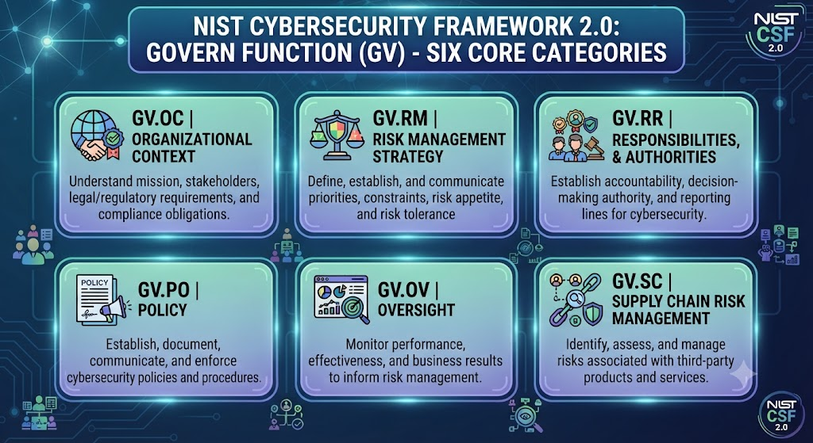
NIST CSF 2.0 organizes the Govern function into six distinct categories that provide a roadmap for leadership:

- Organizational Context (GV.OC): Organizations must understand the circumstances, including mission, stakeholder expectations, and legal/regulatory requirements, that influence cybersecurity risk decisions.
Key Components of GV.OC
The category comprises five subcategories (GV.OC-01 through GV.OC-05) that guide an organization to:
- Understand Mission Alignment: Recognize the organizational mission and ensure it informs cybersecurity risk management decisions.
- Identify Stakeholders: Determine internal and external stakeholders and understand their specific needs and expectations regarding cybersecurity.
- Acknowledge Obligations: Identify and manage legal, regulatory, and contractual requirements, including privacy and civil liberties obligations.
- Analyse Dependencies: * External Reliance: Identify and communicate critical outcomes, capabilities, and services that the organization depends on from external parties.
  - Stakeholder Reliance: Determine and communicate critical objectives, capabilities, and services that stakeholders depend on or expect from the organization

- Risk Management Strategy (GV.RM): This involves establishing and communicating the organization's risk appetite and risk tolerance, ensuring that risk management activities are prioritized according to business objectives.
Risk Apetite is defined as the types and amount of risk an organization is willing to accept in pursuit of its value, mission, or vision and its purpose is to set the high-level boundaries for risk-taking in pursuit of organizational goals.
Risk Tolerance provides the specific, measurable boundaries for that appetite. It defines the upper limit of risk the organization is willing to accept for specific assets, processes, or systems

Concept | Description | Implementation Example
Risk Appetite | The organization's broad posture. | "We have a low appetite for risks that could disrupt primary revenue services."
Risk Tolerance | Specific, measurable thresholds. | "Downtime for [System X] must not exceed 4 hours per quarter."
- Roles, Responsibilities, and Authorities (GV.RR): Governance requires defining exactly who is accountable for cybersecurity decisions. It ensures that security roles are clear across the entire organization, from the board level to individual contributors.
The primary goal of GV.RR is to establish clear accountability. Without defined roles and authorities, cybersecurity efforts often fail due to confusion, lack of budget, or "responsibility gaps" where critical security tasks fall through the cracks.
The Core Components
The category is structured to ensure that everyone from the Board of Directors to the system operators understands their contribution to the organization’s security posture.

- Policy (GV.PO): This category focuses on creating and maintaining formal policies that reflect the organization’s cybersecurity goals, ensuring they are documented and understood.

Subcategory | Focus | Key Objective
GV.RR-01 | Organizational Roles | Defining and communicating clear cybersecurity roles and responsibilities for all personnel.
GV.RR-02 | Organizational Authorities | Ensuring that personnel have the explicit authority to carry out their assigned cybersecurity responsibilities.
GV.RR-03 | Mission-Critical Assets | Designating specific individuals who are responsible for the security of mission-critical assets.
Policy translates the organization’s high-level Risk Appetite and Strategy into actionable, repeatable, and enforceable documents. It bridges the gap between executive intent (the "what we want") and daily operations (the "how we do it").

The Core Components
The GV.PO category focuses on three essential elements of policy management

Subcategory | Focus | Core Objective
GV.PO-01 | Development | Developing and establishing cybersecurity policies that align with the organizational mission and strategy.
GV.PO-02 | Communication | Ensuring that cybersecurity policies are disseminated and understood by all personnel and relevant third parties.
GV.PO-03 | Review and Update | Periodically reviewing and updating policies to ensure they remain relevant to the evolving threat landscape and organizational changes.

- Oversight (GV.OV): Governance involves continuous monitoring of the cybersecurity strategy. It ensures that the organization’s results are reviewed against its stated goals, providing the feedback loop necessary to adjust tactics.
Oversight transforms cybersecurity from a static set of rules into a dynamic, performance-driven program. It moves the needle from "asserting" that security is working to "demonstrating" it through evidence, metrics, and continuous review
- Cybersecurity Supply Chain Risk Management (GV.SC): Recognizing that risks often exist outside the perimeter, this category focuses on governing the risks associated with third-party service providers, suppliers, and external partners., it focuses on the systematic process of identifying, assessing, and managing risks throughout the technology product and service lifecycle, specifically regarding third-party relationships (suppliers, vendors, partners).

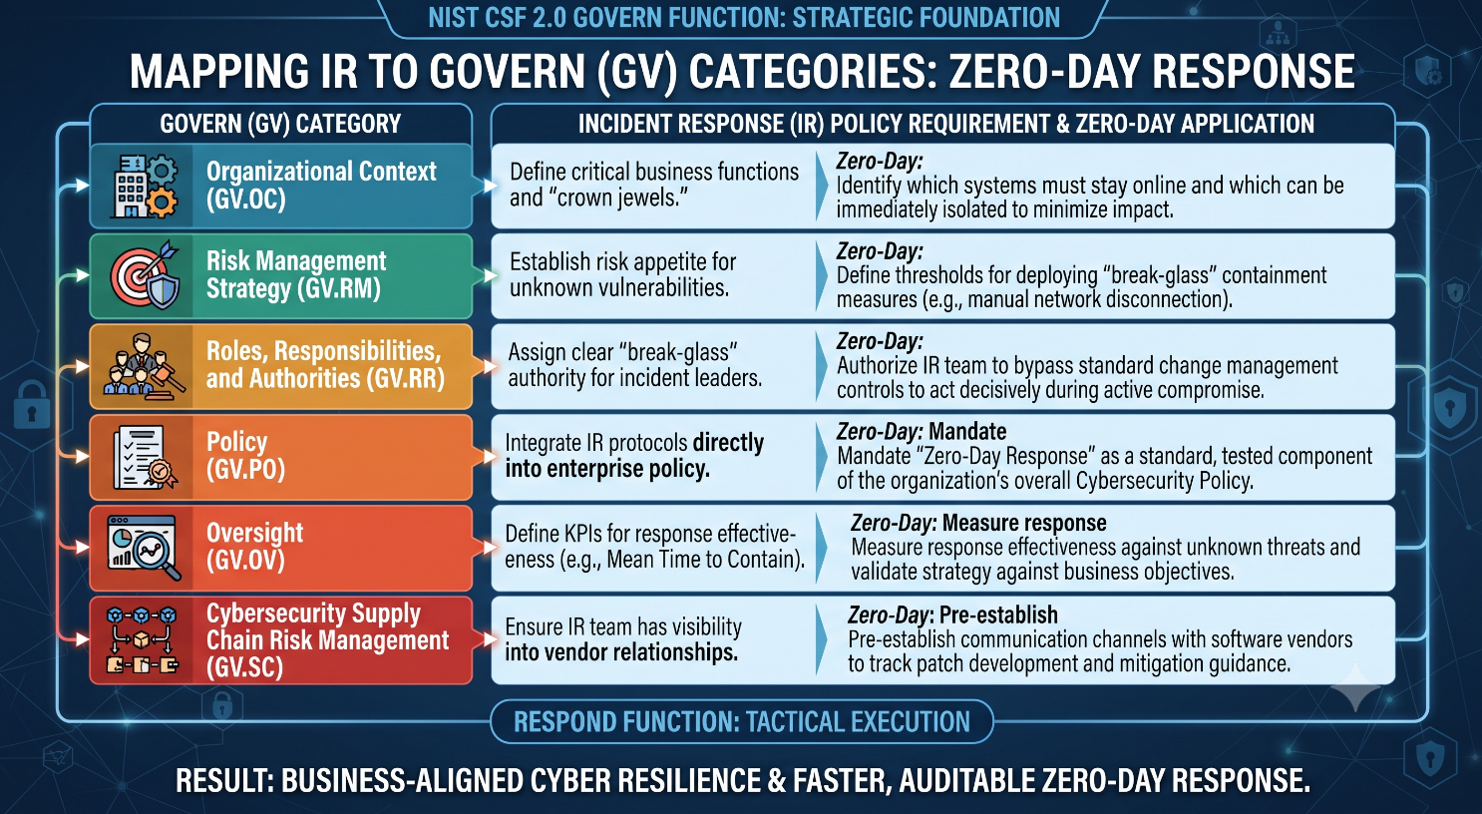

Govern Function Application into Zero-Day Resilience

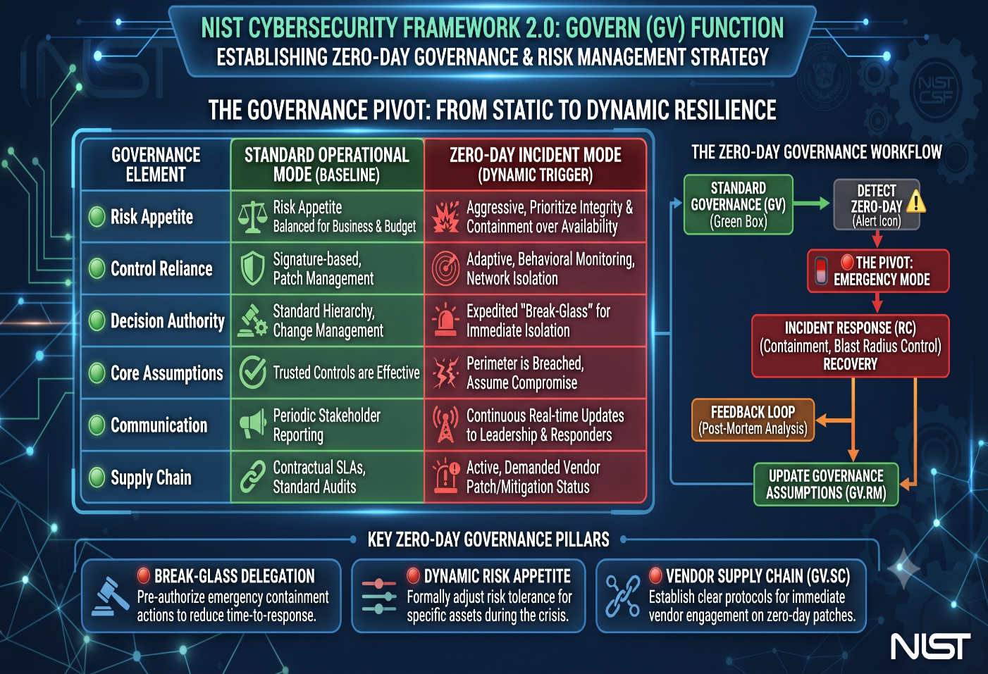

IDENTIFICATION PHASE
If Govern sets the strategy and "rules of the road," Identify provides the map of the environment where those rules are applied. Its core purpose is to develop an organizational understanding of your cybersecurity risk, ensuring you know exactly what you are protecting and why.
The Three Pillars of Identify
While previous versions of the framework included more categories here, CSF 2.0 has streamlined Identify to focus on three essential areas
Category | Focus | Core Objective
Asset Management (ID.AM) | Inventory & Classification | Knowing what you have (hardware, software, data, systems, and services) and prioritizing it based on business value.
Risk Assessment (ID.RA) | Threat & Vulnerability | Understanding the threats to those assets, the potential vulnerabilities, and the likelihood/impact of an incident.
Improvement (ID.IM) | Continuous Growth | Learning from your risk management activities to refine your program over time.

The Core Focus of ID.AM
The Identify function is the foundation for all subsequent actions (Govern, Protect, Detect, Respond, and Recover). ID.AM ensures that your cybersecurity strategy is based on accurate, real-time knowledge of your environment.
Subcategory | Requirement | Objective
ID.AM-01 | Inventory of computing devices | Know exactly what hardware connects to your network.
ID.AM-02 | Inventory of software platforms and applications | Understand the software stack, including OS and critical business apps.
ID.AM-03 | Inventory of data and information | Classify data based on sensitivity and business value.
ID.AM-04 | Inventory of internal and external services | Identify dependencies on third-party cloud or managed services.
ID.AM-05 | Identification of logical and physical dependencies | Map how assets, services, and data interact to support business functions.
ID.AM-06 | Asset roles and responsibilities | Define who owns, manages, and is accountable for each asset.

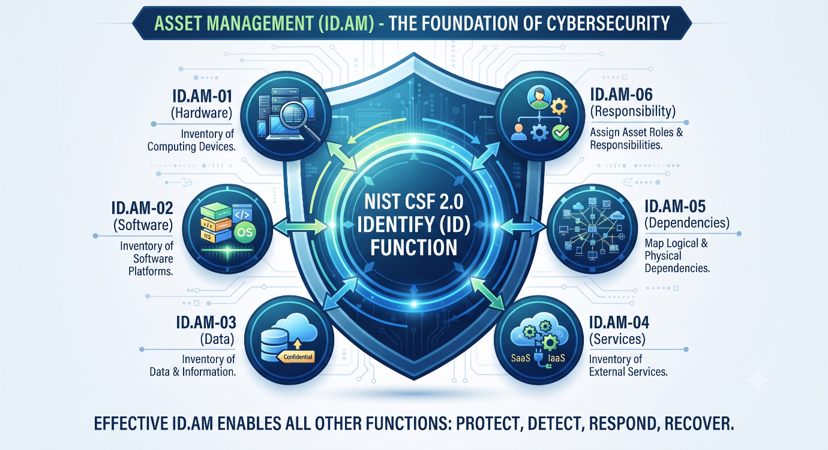

Integrating with Other Functions
Asset Management is not an isolated activity; it feeds the rest of the NIST framework:
- Govern: Your risk appetite and tolerance are applied to specific asset classes (e.g., higher tolerance for non-critical assets; zero tolerance for critical customer data repositories).
- Protect: You cannot apply the correct safeguards (e.g., MFA, encryption) without knowing the type and sensitivity of the asset.
- Recover: During a recovery, the priority is determined by the criticality levels established in the Asset Management phase.

Risk Assessment (ID.RA)
The Core Focus of ID.RA
The primary goal of ID.RA is to move from a list of assets to an understanding of cybersecurity risk to operations, assets, and individuals. It translates technical data into business-relevant insights.
Subcategory | Focus | Key Activity
ID.RA-01 | Vulnerabilities | Identify, validate, and record weaknesses in assets.
ID.RA-02 | Threat Intelligence | Receive and integrate external threat data (TTPs, actors).
ID.RA-03 | Threats | Record both internal and external threats.
ID.RA-04 | Impact & Likelihood | Analyze the probability of exploitation and business impact.
ID.RA-05 | Inherent Risk | Determine risk level to inform prioritization.
ID.RA-06 | Risk Response | Choose, plan, and track the remediation strategy.
ID.RA-07 | Change Management | Assess risk impact of configuration changes or exceptions.
ID.RA-08 | Vulnerability Disclosure | Establish processes to handle external vulnerability reports.
ID.RA-09 | Acquisition Integrity | Verify hardware/software integrity before use.
ID.RA-10 | Supplier Assessment | Assess critical suppliers prior to engagement.

The "Risk Triangle": AM, RA, and RM
To implement ID.RA effectively, it must be tightly coupled with the other functions you’ve been focusing on:
- ID.AM (Asset Management): Provides the "subject" of the assessment. You assess risks to the assets identified in your inventory.
- ID.RA (Risk Assessment): Provides the "verdict." It calculates the impact and likelihood of a threat exploiting a vulnerability on those assets.
- GV.RM (Risk Management Strategy): Provides the "threshold." Your Risk Tolerance (from the Govern function) is the benchmark used in ID.RA-06 to decide whether to Accept, Mitigate, Transfer, or Avoid the risk.

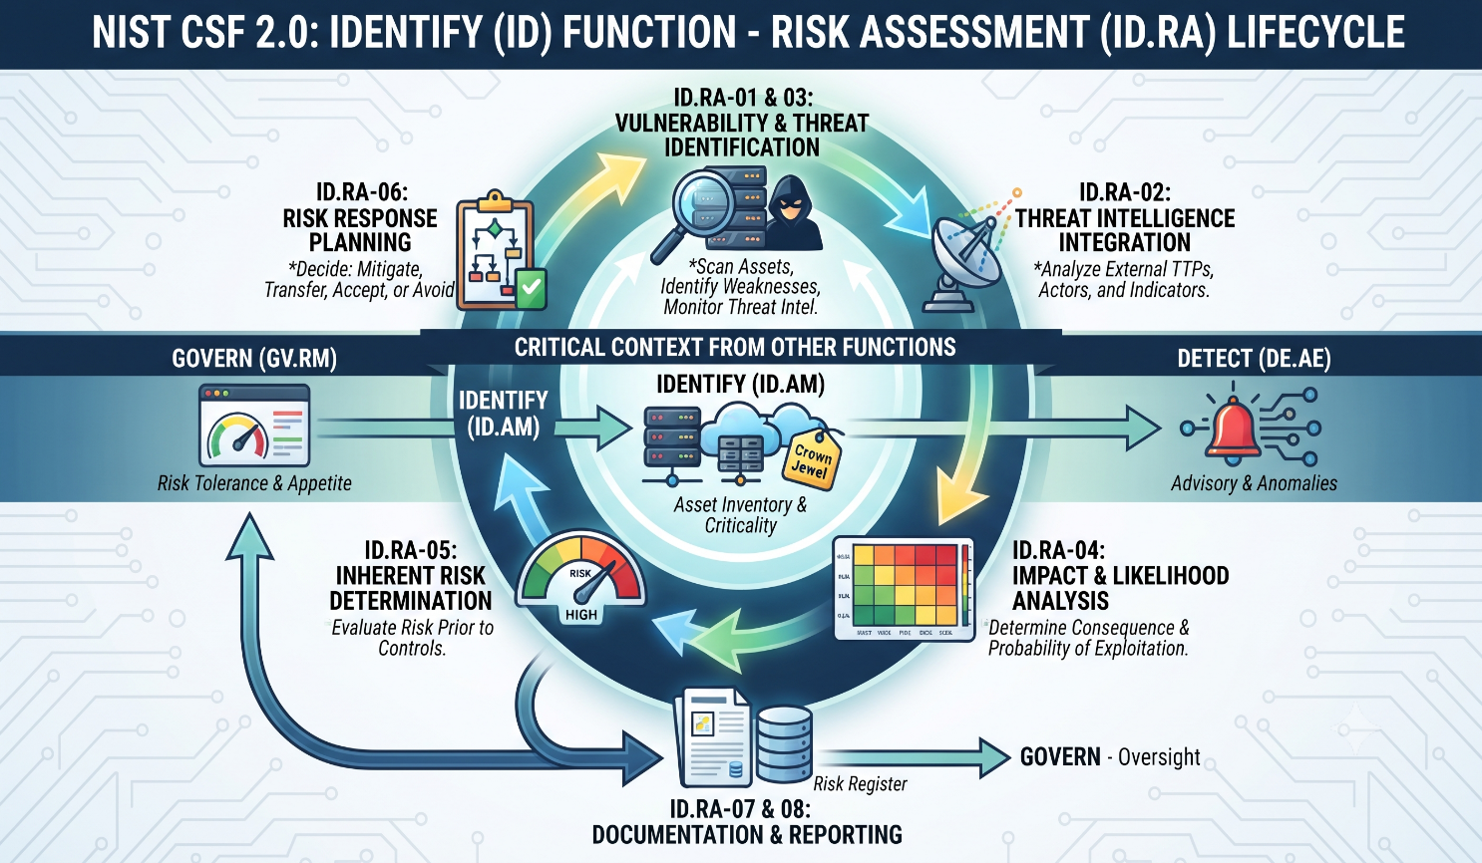
Improvement (ID.IM)
The primary outcome of ID.IM is the continuous refinement of the organization’s cybersecurity program. It transitions the organization from a static security model to one of continuous improvement, ensuring that past experiences (both internal successes/failures and external industry trends) are actively used to strengthen defenses.

Key Subcategories of ID.IM
The Improvement category focuses on formalizing the process of learning and adapting:
- ID.IM-01: Improvement Planning: The organization communicates and implements improvements based on the results of previous activities and assessments. This ensures that findings from audits, exercises, and real-world incidents are not ignored but are turned into actionable projects.
- ID.IM-02: Lessons Learned: The organization identifies and documents lessons learned from internal and external activities, including cybersecurity incidents, to improve the cybersecurity program.
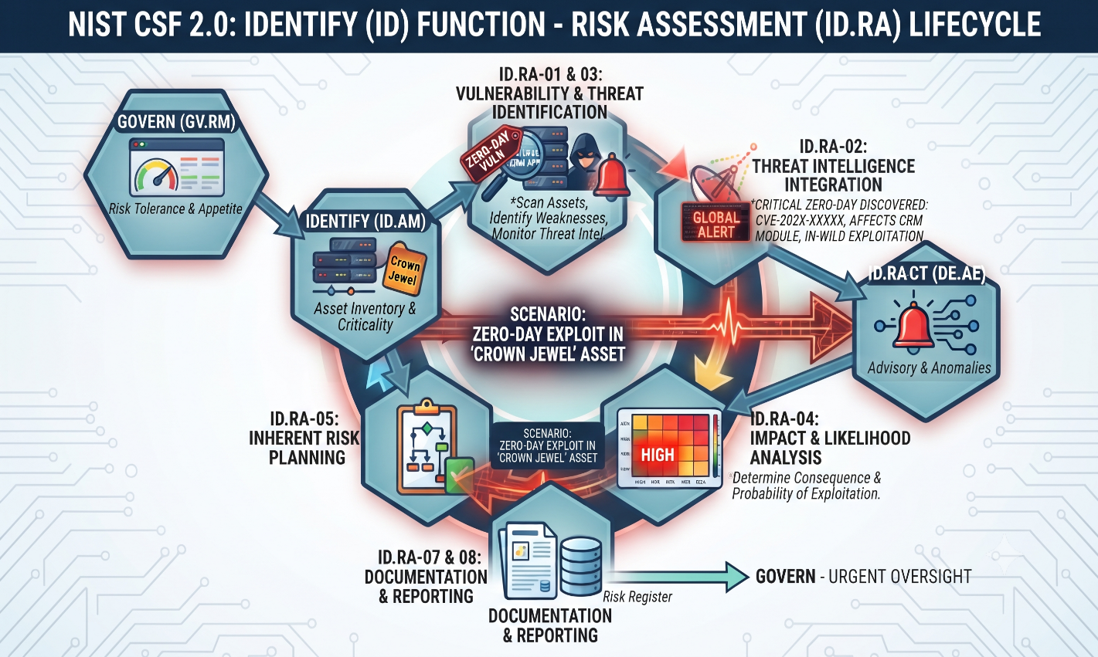
  - Note: This is where the post-incident analysis from the Recover function feeds back into the Identify function.

PROTECTION PHASE

The 72-hrs Response Timeline
Phase | Timeframe | Objective | Key Actions
1. Detect | Hour 0–6 | Identify that an exploit exists | Correlate monitoring alerts, threat intelligence feeds, and vendor or CERT disclosures to confirm the vulnerability is real and relevant to your environment.
2. Contain | Hour 6-24 | Stop the bleeding | Isolate affected systems, cut off attacker access paths, and apply emergency compensating controls (firewall rules, account lockdowns) while a permanent fix is prepared.
3. Remediate | Hour 24–48 | Close the vulnerability | Test the vendor patch or a validated workaround in staging, then deploy it in waves across all affected systems, prioritizing internet-facing and high-value assets first.
4. Verify | Hour 48–72 | Confirm the incident is closed | Scan for residual compromise, confirm full patch coverage, restore normal operations, and update policy based on lessons learned.

Why 72 Hours?
Seventy-two hours is a deliberately tight but achievable target. It's long enough to properly test a patch before mass deployment, but short enough to keep urgency high and stop response efforts from drifting. Many regulatory breach-notification windows (for example, 72-hour rules under GDPR-aligned frameworks) also anchor to this timeframe, so the blueprint doubles as a structure for meeting external reporting obligations.

Protection
Vendors typically need time to develop, test, and release a fix once a zero-day is disclosed. During that gap, the organization is exposed but not defenseless. Five categories of controls reduce that exposure:
- EDR & Antivirus: Endpoint Detection and Response (EDR) tools, paired with traditional antivirus, watch for the behavioral signatures of exploitation, like unusual process spawning, memory injection, privilege escalation (even when the specific exploit is unknown).
- Firewalls, IDS & IPS: Firewalls, intrusion detection systems (IDS), and intrusion prevention systems (IPS) can be tuned with emergency signatures or rules as soon as indicators of compromise are published, blocking known exploit traffic at the perimeter.
- Network Segmentation: Segmenting the network limits how far an attacker can move if a system is compromised. Isolating affected systems turns a potential organization-wide incident into a contained one.
- Principle of Least Privilege: Enforcing least privilege ensures that even a successfully exploited account or service has limited reach, reducing the blast radius of any single compromise.
- Monitor Systems & Traffic: Continuous monitoring of systems and network traffic is what makes early detection possible in the first place, and it remains essential throughout containment to confirm controls are holding.

DETECTION PHASE

RESPONSE PHASE

RECOVERY PHASE
When a cyberattack hits, recovery is the stage where an organization gets its systems and services working safely and normally. In our investigation we used the NIST Cybersecurity Framework (a widely used, free U.S. government playbook for managing cyber risk) approach.
What “Recovery” means
In the framework, Recovery (the RECOVER function) is simply this: restore the assets and operations that the incident affected. The goal is to bring things back to normal, safely and in good timing, while keeping people informed. It has two parts: getting systems back up (Incident Recovery Plan Execution, RC.RP) and keeping everyone informed (Incident Recovery Communication, RC.CO).

The recovery steps, in order
Recovery is a careful, verified sequence:
- Execute the plan. Start the recovery plan you prepared in advance (Eg, Playbooks, Manuals, etc.).
- Prioritize. Decide what to restore first, based on what matters most.
- Verify backups. Check that your backups (saved copies of data) are clean and trustworthy before using them.
- Restore and confirm. Restore the systems and confirm they are truly back to normal.
- Set new norms. Set new, safer “normal” rules for operating after the incident.
- Close it out. Officially declare recovery finished, but only when it meets agreed criteria and all the important points of the attack have been documented.
The golden rule: trust, but verify. Check backups before you use them, and check restored systems afterward.

Why a zero-day makes recovery harder
A zero-day breaks three things we normally take for granted:
- No fix exists yet. You might restore a system only to find it is still open to the same attack. Until the vendor releases a patch, you must add temporary protections (“compensating controls”).
- Your backups might already be infected. Attackers often get in well before anyone notices, so even saved copies can hide their tools. That is why you verify backups first.
- The attacker might survive the cleanup. Some malicious code can outlast a restart, or even a full factory reset.
Real example: In 2025, for a set of zero-day flaws in Cisco security devices, the U.S. cyber agency CISA warned that rebooting was not enough and required a physical hard reset, because the malware had buried itself in the device's read-only memory. In the worst cases, “recovery” means rebuilding from scratch or even replacing hardware.

Trusted tools that help
- MITRE D3FEND: Its “Restore” step describes how to return systems to a known-good state.
- CVSS 4.0: Version 4 adds a “Recovery” label that flags whether a system can bounce back automatically, needs a person to fix it, or is beyond repair.
- CISA: This U.S. Agency offers free help: an “Eviction Strategies” tool for removing attackers, a public list of vulnerabilities known to be under active attack (the KEV catalog), and emergency directives that set deadlines to act while no patch exists.
- NIST SP 800-184: a dedicated guide on cyber-event recovery (how to plan it, practice it, and measure it).

Communicate and confirm
Recovery isn't done until it is both verified and communicated. Keep people updated (customers, partners, regulators) and share public updates through approved channels. Declare “all clear” only when it meets agreed criteria. With a zero-day, whose full reach may be unknown, it is wise not to rush that call. Finally, turn the experience into lessons that strengthen future defenses.

Bibliography
https://docs.fortinet.com/document/fortigate/7.4.2/ngfw-atp-concept-guide/868490/statistical-anomaly-based-detection
https://fastercapital.com/content/Anomaly-Detection--Detecting-Suspicious-Behavior-with-IPS.html
https://en.wikipedia.org/wiki/Anomaly-based_intrusion_detection_system
https://letsdefend.io/blog/nist-incident-response-preparation-phase
https://nvlpubs.nist.gov/nistpubs/specialpublications/nist.sp.800-184.pdf
https://nvlpubs.nist.gov/nistpubs/specialpublications/nist.sp.800-61r2.pdf
https://doi.org/10.6028/NIST.SP.800-61r3
https://doi.org/10.6028/NIST.CSWP.29
https://baconunlimited.com/zero-day-vulnerability-response-plan/
https://www.taylorwessing.com/de/global-data-hub/2025/digital-resilience-and-cyber-security/gdh---monitoring-preparedness-and-governance-under-eu-cyber-security-legislation
https://safe.security/resources/insights/nist-cybersecurity-framework/
https://en.wikipedia.org/wiki/NIST_Cybersecurity_Framework#:~:text=Organizational%20Context%20(GV.,Risk%20Management%20Strategy%20(GV.

https://www.mimecast.com/content/cybersecurity-governance/#:~:text=By%20defining%20clear%20governance%20policies,a%20robust%20cybersecurity%20governance%20program.
https://www.vectra.ai/topics/zero-day#:~:text=threat%20in%20advance.-,What%20is%20a%20zero%2Dday%20vulnerability%3F,before%20attackers%20can%20exploit%20it.
https://www.manageengine.com/compliance-manager/nist-csf-compliance/nist-csf-respond-function.html#:~:text=Activities%20related%20to%20incident%20management,event%20analysis%20and%20lessons%20learned.
https://safe.security/resources/insights/nist-cybersecurity-framework/
https://csf.tools/reference/nist-cybersecurity-framework/v2-0/gv/#:~:text=The%20organization's%20priorities%2C%20constraints%2C%20risk,%3A%20Roles%2C%20Responsibilities%2C%20And%20Authorities
https://csrc.nist.rip/Projects/Cybersecurity-Framework/Filters#/csf/filters
https://www.paloaltonetworks.com/cyberpedia/what-is-nist-csf#:~:text=2.0%20Core%20Functions-,Function,Secure%20critical%20assets%20and%20infrastructure
https://csrc.nist.gov/glossary/term/zero_day_attack
Dempsey, K., et al. (n.d.). Automation Support for Security Control Assessments (NISTIR 8011, Vol. 3). National Institute of Standards and Technology.
https://www.cisa.gov/known-exploited-vulnerabilities-catalog
https://cloud.google.com/blog/topics/threat-intelligence/2024-zero-day-trends
https://www.cisa.gov/known-exploited-vulnerabilities-catalog
https://www.cisa.gov/news-events/directives/ed-25-03
https://www.cisa.gov/resources-tools/resources/eviction-strategies-tool
https://d3fend.mitre.org/tactic/d3f:Restore/
https://www.first.org/cvss/v4.0/specification-document
https://doi.org/10.6028/NIST.SP.800-61r3
https://doi.org/10.6028/NIST.SP.800-184
https://doi.org/10.6028/NIST.CSWP.29

